Azure Data Bricks

Databricks vs Synapse
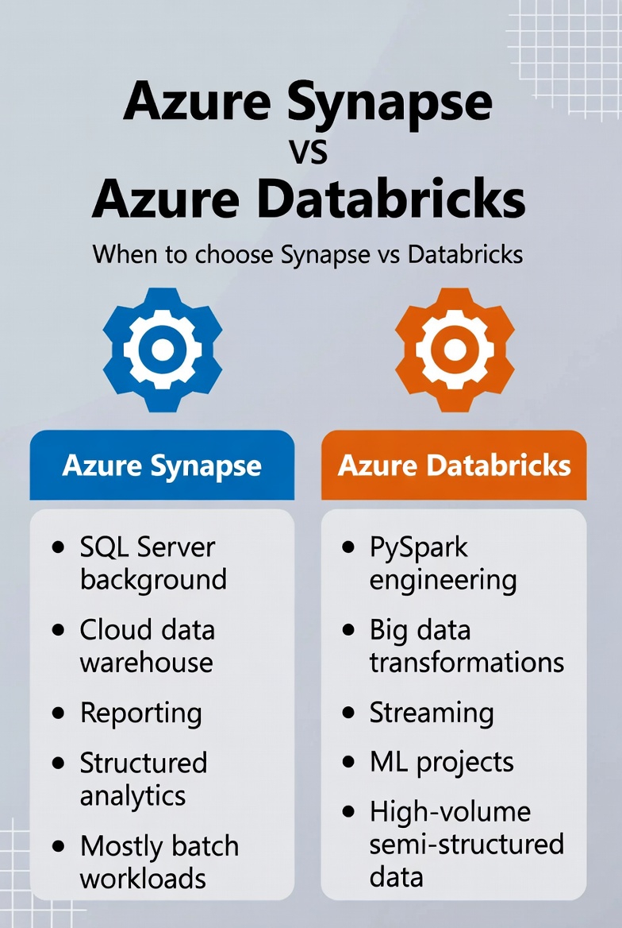

Your selection should be based on below –
Choose Synapse if:
- You come from SQL Server/SQL background (like you do Vijay garu)
- You want:
  - Cloud data warehouse
  - Reporting
  - Structured analytics
- Mostly batch workloads

Choose Databricks if:
- You need to work:
  - PySpark engineering
  - Big data transformations
  - Streaming
  - ML projects
- High-volume semi-structured data

Quick comparison:
Area | Synapse | Databricks
Primary Focus | Data warehouse + BI | Big data + Spark
SQL Performance | ⭐⭐⭐⭐⭐ | ⭐⭐⭐⭐
Spark Performance | ⭐⭐⭐ | ⭐⭐⭐⭐⭐
ETL Pipelines | Built-in | Built-in (Jobs/Workflows)
Streaming | Basic | Excellent
ML / AI | Limited | Strong
Ease for SQL Devs | Very easy | Medium
Enterprise Reporting | Excellent | Needs BI layer

Data Bricks Workspace UI:

Work Space -> New
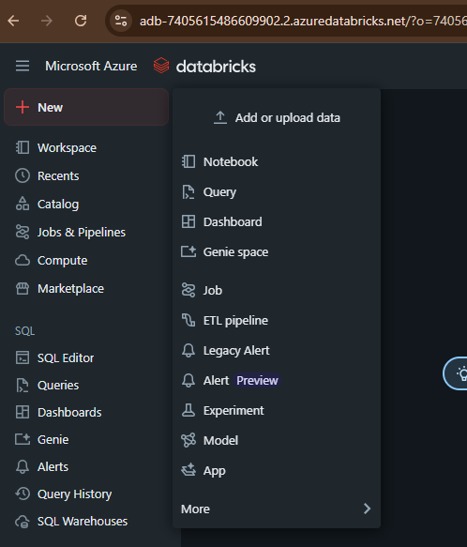
Add or upload data
Purpose: Bring data into Databricks
Used for:
- Upload CSV, JSON, Excel (small files)
- Connect to cloud storage (ADLS, Blob, S3)
Mostly for testing, POCs, or quick demos
Production usually uses pipelines instead

Notebook (MOST IMPORTANT)
Purpose: Write code
Used for:
- PySpark transformations
- SQL queries
- data exploration
- ETL logic
80–90% of Databricks work happens here

Query
Purpose: Pure SQL workspace
Used for:
- Writing SQL on Delta tables
- Creating datasets for dashboards
- Analytics/reporting
Think:
Like SQL Server Management Studio but cloud-native

Dashboard
Purpose: Visual reports inside Databricks
Used for:
- KPIs
- charts
- operational analytics
Similar to:
- Power BI (lightweight version)
Often built from Queries.

Genie space
Purpose: AI-powered natural language analytics
Used for:
- Ask questions like:
“Show sales by month”
- Auto-generate SQL & insights
More of a modern AI assistant for business users.

Job
Purpose: Automation & scheduling
Used for:
- Run notebooks on schedule
- Orchestrate workflows
Examples:
- Run ETL every night
- Trigger pipeline every hour
Equivalent to:
SQL Agent Jobs / Cron jobs

ETL pipeline (Delta Live Tables)
Purpose: Production-grade data pipelines
Used for:
- Bronze → Silver → Gold architecture
- Streaming + batch
- Data quality checks
This is enterprise ETL in Databricks.
Best for:
large-scale systems
automated transformations

Legacy Alert / Alert (Preview)
Purpose: Monitoring & notifications
Used for:
- Notify when data crosses threshold
- Pipeline failures
- KPI drops
Example:
- Alert if daily sales < target

Experiment
Purpose: ML experiment tracking
Used for:
- Model runs
- parameters
- metrics
- comparisons
Mostly for data scientists.

Model
Purpose: Register & manage ML models
Used for:
- Versioning models
- deploying models
- lifecycle control
ML production layer.

App
Purpose: Build data apps
Used for:
- internal tools
- analytics apps
- ML-powered UI
Less common for pure data engineering.

Simple memory trick
Want to… | Click
Code | Notebook
Automate | Job
Build ETL | ETL pipeline
Analyze SQL | Query
Visualize | Dashboard
Upload data | Add data

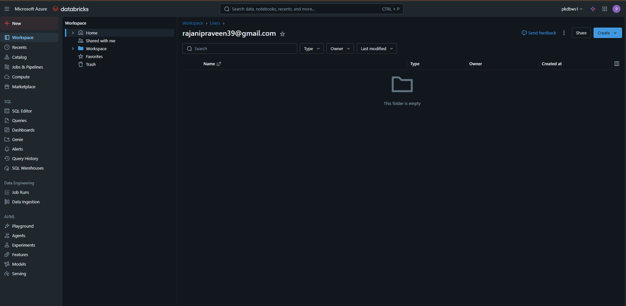
Workspace
Your project folder system:
- Notebooks
- Repos (GitHub/Azure DevOps connected code)
- Files
Think of it as your Databricks project drive

Recents
Recently opened:
- Notebooks
- Queries
- Dashboards
Productivity shortcut
Catalog (Unity Catalog)
Catalog
Central data governance layer:
- Databases (schemas)
- Tables
- Views
- Permissions
- Data lineage
Where your Lakehouse data lives securely
Typical hierarchy:
Catalog → Schema → Table
Example:
sales_catalog.raw.orders

Orchestration & Compute
Jobs & Pipelines
Automated workloads:
Jobs:
- Schedule notebooks
- Run Python scripts
- Trigger workflows
Pipelines:
- Delta Live Tables (streaming + batch ETL)
This is your production automation engine

Compute
Where Spark runs:
- Clusters (interactive & job)
- Serverless compute
Without compute → nothing executes

Marketplace
Prebuilt assets:
- Sample datasets
- ML models
- Partner connectors
- Industry solutions
Accelerators for real projects

SQL & Analytics Layer (very important for BI)
SQL Editor
Write:
- SQL queries on Delta tables
- Views
- Transformations

Queries
Saved SQL queries for reuse

Dashboards
BI-style dashboards inside Databricks
(KPIs, charts, filters)
Like lightweight Power BI inside Databricks

Genie
AI-powered:
- Ask data questions in plain English
- Auto-generate SQL

Alerts
Triggers on SQL results:
Example:
- Sales drop below threshold → send email/Teams

Query History
Audit of all SQL executed:
- Performance
- Who ran what
- When

SQL Warehouses
Dedicated SQL compute layer:
- Fast analytics
- Power BI/Tableau connectivity
Think: Databricks SQL engine

🛠 Data Engineering Section
Job Runs
Execution history:
- Success/failures
- Logs
- Runtime
Debugging production pipelines

Data Ingestion
UI-driven ingestion tools:
- Auto Loader
- File uploads
- Streaming sources
No-code/low-code ingestion

🤖 AI / Machine Learning Layer
Playground
Experiment with:
- LLMs
- GenAI prompts
- Model testing

Agents
AI agents that:
- Query data
- Run workflows
- Answer business questions

Experiments
MLflow tracking:
- Model versions
- Metrics
- Parameters
Used by data scientists

Features
Feature Store:
- Reusable ML features
- Consistent training & inference

Models
Model registry:
- Store trained models
- Promote to production

Serving
Real-time APIs for ML/AI models:
Example:
POST /predict → fraud score
Makes Databricks a live AI platform

Simple Mental Model (helps a LOT)
Area | Purpose
Workspace | Your code & notebooks
Catalog | Your governed data
Compute | Spark power
Jobs/Pipelines | Automation
SQL tools | Analytics & BI
Data Ingestion | Bringing data in
AI/ML | Models & GenAI

